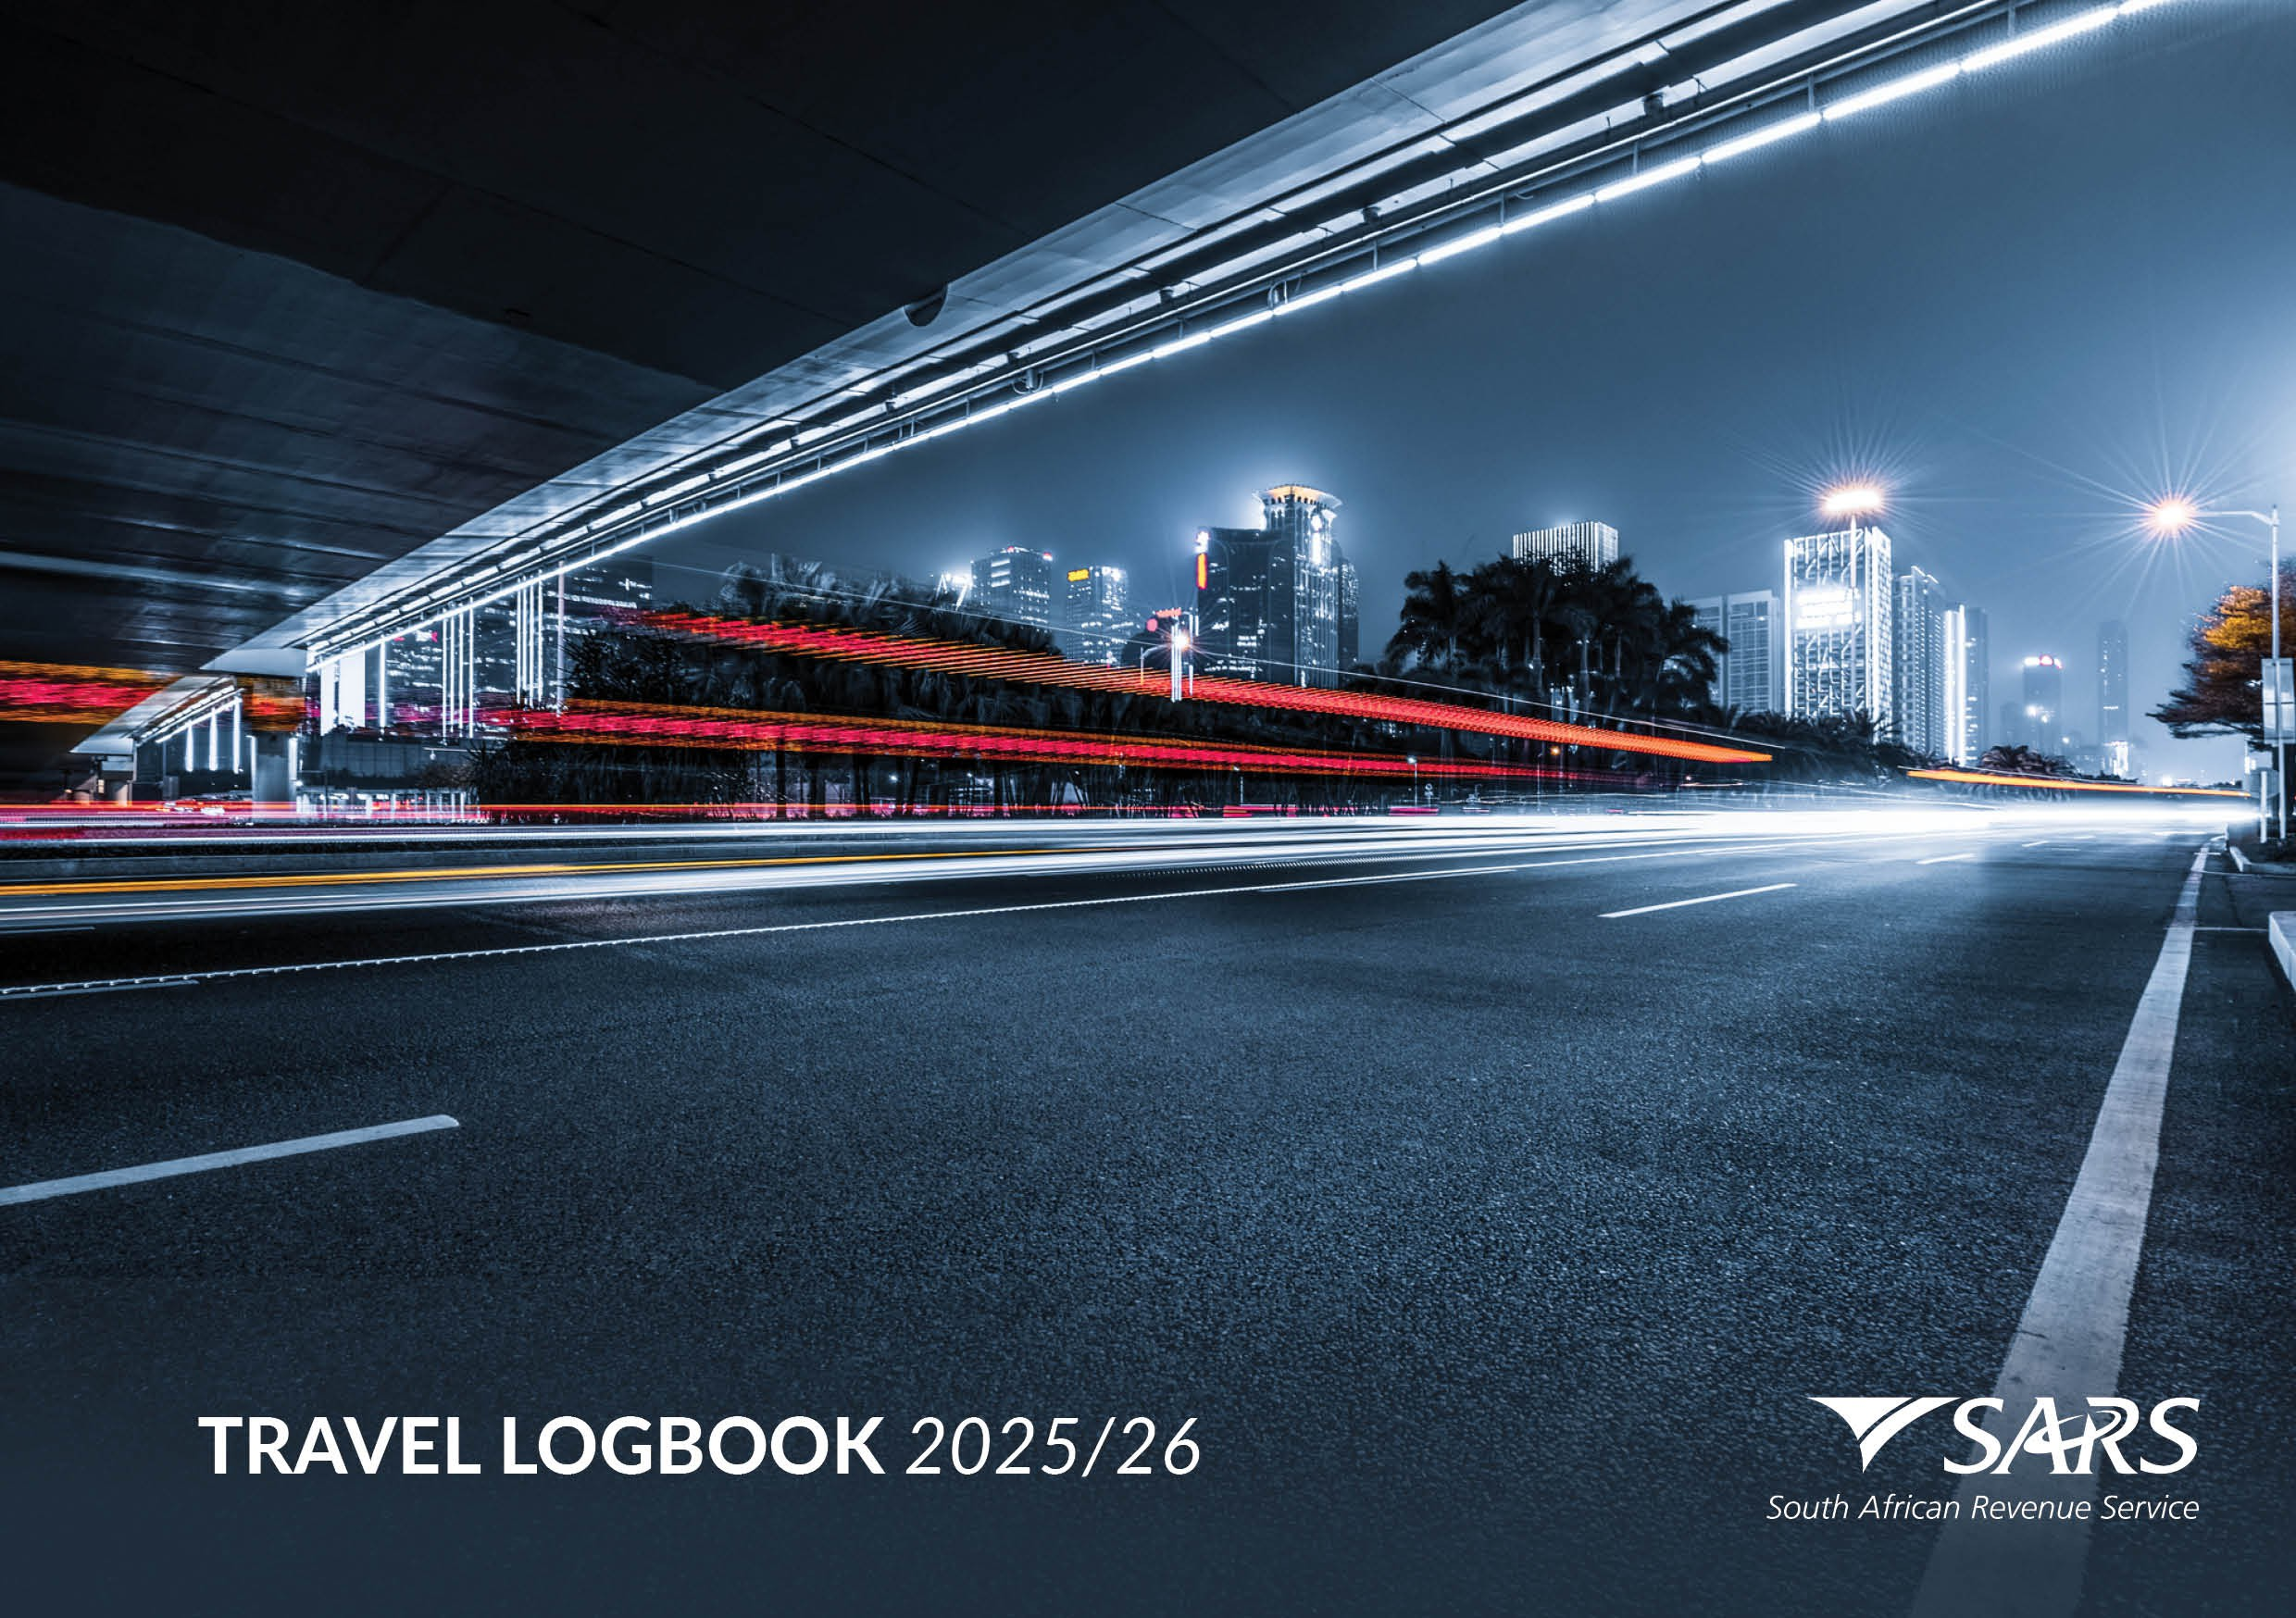

INTRODUCTION

Calculating a travel deduction if you are in receipt of a travel allowance

The Income Tax Act No.58 of 1962 allows taxpayers who receive a travel allowance to claim a deduction for the use of their private vehicles for business purposes. It is important to note that travel between your home and place of work cannot be claimed and is regarded as private travel.

In order to claim a deduction, the first step is to record your vehicle’s odometer reading on 1 March each year (the first day of the tax year for individuals), and again on the last day of February the following year (the last day of the tax year for individuals). The difference between the closing and opening readings will give you your total kilometres travelled for the year.

Without these readings, you cannot claim a tax deduction!
Once you have taken down these readings and worked out your total travel for the year, you can start calculating your travel deduction.
First you need to calculate what portion of the total kilometres travelled was for business use.

It is now compulsory to keep a logbook of all your travel in which you record your business kilometres if you want to claim a travel deduction. The logbook must contain the following minimum information relating to your business travel:
- Date of travel
- Kilometres travelled
- Travel details (where to and reason for the trip)
Note: Where you used more than one vehicle in the tax year, a separate logbook must be kept for each vehicle that was used.

Without a logbook, you will not be able to claim a travel deduction.
You are now ready to calculate the amount of your claim. As a taxpayer you have two choices:
- You can calculate your claim based on the table of costs supplied by SARS each year. You will find the cost tables which apply to the tax year from 1 March 2025 to 28 February 2026 on the next page of this logbook. You need not have kept an accurate record of all your expenses – simply use the costs linked to the value of your vehicle.

- Alternatively, you can calculate your claim based on the actual costs. You will have to have kept an accurate record of all your expenses during the year, including fuel, maintenance, lease and insurance costs.

Please note that you must retain your logbook for a period of at least five years as you may be required to submit it to SARS for verification of your claim. SARS accepts electronic logbooks as an acceptable record.

The South African Revenue Service reserves the right to audit and query the content or information recorded by the taxpayer in any logbook.

Fixed Cost Table: 1 March 2025 - 29 February 2026

Rates per kilometre, which may be used in determining the allowable deduction for business travel against an allowance or advance where actual costs are not claimed, are determined by using the following table:

Where the value of  the vehicle | Fixed cost  (R) | Fuel cost  (c/km) | Maintenance  cost (c/km)
does not exceed R100 000 | 33,940 | 146.7 | 47.4
exceeds R100 000 but does not exceed R200 000 | 60,688 | 163.8 | 59.3
exceeds R200 000 but does not exceed R300 000 | 87,497 | 177.9 | 65.4
exceeds R300 000 but does not exceed R400 000 | 111,273 | 191.4 | 71.4
exceeds R400 000 but does not exceed R500 000 | 135,048 | 204.8 | 83.9
exceeds R500 000 but does not exceed R600 000 | 159,934 | 234.9 | 98.5
exceeds R600 000 but does not exceed R700 000 | 184,867 | 238.9 | 110.5
exceeds R700 000 but does not exceed R800 000 | 211,121 | 242.9 | 122.5
exceeding 800 000 | 211,121 | 242.9 | 122.5

Simplified method
Where:
- The provisions of section 8(1)(b)(iii) are applicable in respect of the recipient of an allowance or advance; and
- No other compensation in the form of a further allowance or reimbursement (other than for parking or toll fees) is payable by the employer to that recipient, that rate per kilometre is, at the option of the recipient, equal to 476 cents per kilometre.

Note:
- 80% of the travelling allowance must be included in the employee’s remuneration for the purposes of calculating PAYE. The percentage is reduced to 20% if the employer is satisfied that at least 80% of the use of the motor vehicle for the tax year will be for business purposes.
- No fuel cost may be claimed if the employee has not borne the full cost of fuel used in the vehicle, and no maintenance cost may be claimed if the employee has not borne the full cost of maintaining the vehicle (e.g. if the vehicle is covered by a maintenance plan).
- The fixed cost must be reduced on a pro-rata basis if the vehicle is used for business purposes for less than a full year.
- The actual distance travelled during a tax year, and the distance travelled for business purposes substantiated by a log book, are used to determine the costs which may be claimed against a travelling allowance.
Alternatively: Where an allowance or advance is based on the actual distance travelled by the employee for business purposes, no tax is payable on an allowance paid by an employer to an employee, up to the rate published on the SARS website www.sars.gov.za under Legal Counsel / Secondary Legislation / Income Tax Notices / Fixing of rate per kilometre in respect of motor vehicles, regardless of the value of the vehicle.
However, this alternative is not available if other compensation in the form of an allowance or reimbursement (other than for parking or toll fees) is received from the employer in respect of the vehicle.
Note: The rates in the Fixed Cost Table are adjusted periodically. The rates in the table on this page relate only to the 2025/26 tax year, i.e. from 1 March 2025 – 29 February 2026.

Company Cars
Employees may also be entitled to claim a reduction on the fringe benefit in respect business mileage travelled in motor vehicles provided by an employer. In order to claim such a deduction, an accurate record of mileage travelled is required. This logbook may also be used for this purpose. The same minimum information as set out above is also required for company cars. For the rates for other tax years please visit www.sars.gov.za or call the SARS Contact Centre on 0800 00 7277.

PRIMARY INFORMATION TO BE FURNISHED BY A TAXPAYER AS REQUIRED BY SARS

TOTAL
Opening kilometres at the beginning of the year of assessment
Closing kilometres at the end of the year of assessment

DAILY BUSINESS TRAVEL RECORDS

Date | Kilometre Recording |  | Total Business Kms | Business Travel Details |  |  | Actual Fuel & Oil Costs (R) | Actual Repairs & Maintenance Costs (R)
 | *Opening Kilometres | *Closing Kilometres |  | From | To | Reason
TOTAL

DAILY BUSINESS TRAVEL RECORDS
Date | Kilometre Recording |  | Total Business Kms | Business Travel Details |  |  | Actual Fuel & Oil Costs (R) | Actual Repairs & Maintenance Costs (R)
 | *Opening Kilometres | *Closing Kilometres |  | From | To | Reason
TOTAL

DAILY BUSINESS TRAVEL RECORDS
Date | Kilometre Recording |  | Total Business Kms | Business Travel Details |  |  | Actual Fuel & Oil Costs (R) | Actual Repairs & Maintenance Costs (R)
 | *Opening Kilometres | *Closing Kilometres |  | From | To | Reason
TOTAL

DAILY BUSINESS TRAVEL RECORDS
Date | Kilometre Recording |  | Total Business Kms | Business Travel Details |  |  | Actual Fuel & Oil Costs (R) | Actual Repairs & Maintenance Costs (R)
 | *Opening Kilometres | *Closing Kilometres |  | From | To | Reason
TOTAL

DAILY BUSINESS TRAVEL RECORDS
Date | Kilometre Recording |  | Total Business Kms | Business Travel Details |  |  | Actual Fuel & Oil Costs (R) | Actual Repairs & Maintenance Costs (R)
 | *Opening Kilometres | *Closing Kilometres |  | From | To | Reason
TOTAL

DAILY BUSINESS TRAVEL RECORDS
Date | Kilometre Recording |  | Total Business Kms | Business Travel Details |  |  | Actual Fuel & Oil Costs (R) | Actual Repairs & Maintenance Costs (R)
 | *Opening Kilometres | *Closing Kilometres |  | From | To | Reason
TOTAL

DAILY BUSINESS TRAVEL RECORDS
Date | Kilometre Recording |  | Total Business Kms | Business Travel Details |  |  | Actual Fuel & Oil Costs (R) | Actual Repairs & Maintenance Costs (R)
 | *Opening Kilometres | *Closing Kilometres |  | From | To | Reason
TOTAL

DAILY BUSINESS TRAVEL RECORDS
Date | Kilometre Recording |  | Total Business Kms | Business Travel Details |  |  | Actual Fuel & Oil Costs (R) | Actual Repairs & Maintenance Costs (R)
 | *Opening Kilometres | *Closing Kilometres |  | From | To | Reason
TOTAL

DAILY BUSINESS TRAVEL RECORDS
Date | Kilometre Recording |  | Total Business Kms | Business Travel Details |  |  | Actual Fuel & Oil Costs (R) | Actual Repairs & Maintenance Costs (R)
 | *Opening Kilometres | *Closing Kilometres |  | From | To | Reason
TOTAL

